PRC Configuration

General Site.

- What color should the header and footer be?
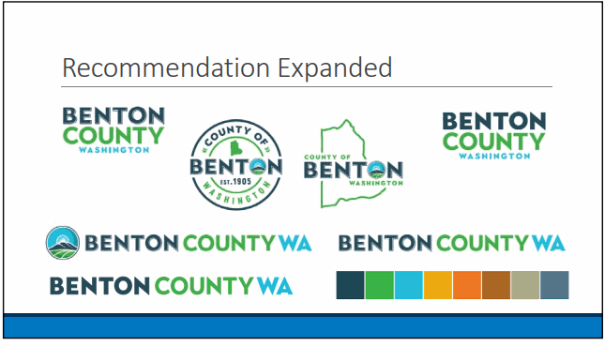
- What is the site name? Displayed in the header

- What is the header logo?

- What text should be shown in the Welcome Screen section? Can add as much or as little as needed (Welcome screen, figure 1)

Welcome to the new Real Property Search!

You can search (in the search box above) using one of several different criteria, such as:
- Full or partial street address or name
- Business Name
- Parcel Number
- Use the pull down menus to search by:
  - Number of bedrooms and bathrooms
  - Year built
  - Lot or building size
  - And more...

The property search provides various information on the selected property.
You can obtain:
- A Property Record Card
- Permit Information
- View and pay tax bill
- View sales of comparable properties (Comper)
- Property value information
- Sales Information
- View property on a map
- View community information (Analytics)

Thank you for using our Web site!

- What text should be shown for the Disclaimer? shown site wide. (Disclaimer, Figure 1)

Disclaimer
All information contained herein, is considered in the public domain and is distributed without warranty of any kind, implied, expressed or statutory. The Benton County Assessor & Treasurer make no claims, promises or guarantees about the accuracy, completeness, or adequacy of this information and expressly disclaims liability for any errors and omissions.
Information relating to 2018 should be considered a ''work in progress''. Prior year data is informational only and does not necessarily replicate the values certified to the tax office.

- The PRC background can optionally be changed. The replacement image must be a large high-resolution image.

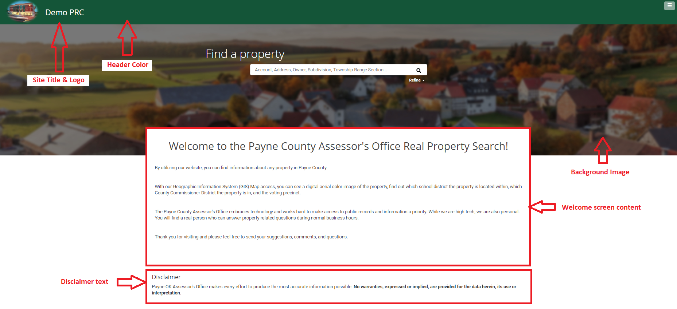
Figure 1

Search and Search Results.

- The search results consist of a thumbnail, 3 items of information max and the assessed value. What information should be display here? Generally, Parcel ID, Owner and Location is shown for example (Result list, Figure 2) Looks good.

- What fields can a user search in the search bar? Parcel ID, Location, Owner etc
Prop_id, Location, Owner

- What fields should be included in the order by dropdown?
I like how Payne County has all of theres in one thing without a dropdown….is there a way to do both?
Fields: Property ID (Prop_ID), Parcel#/Geo ID:, Address, Section, Township Range, Subdivision (abs_sub), Neighbourhood,

- What search filters can be applied to a search? (Search Filters, Figure 2) This can be date fields, text input, range fields or dropdown options.
Use the pull down menus to filter by:
- Sale Date
- Sale Price
- Year Built
- Total Area
- Neighborhood
- Subdivision
- Lot Size
- Lot Size Type

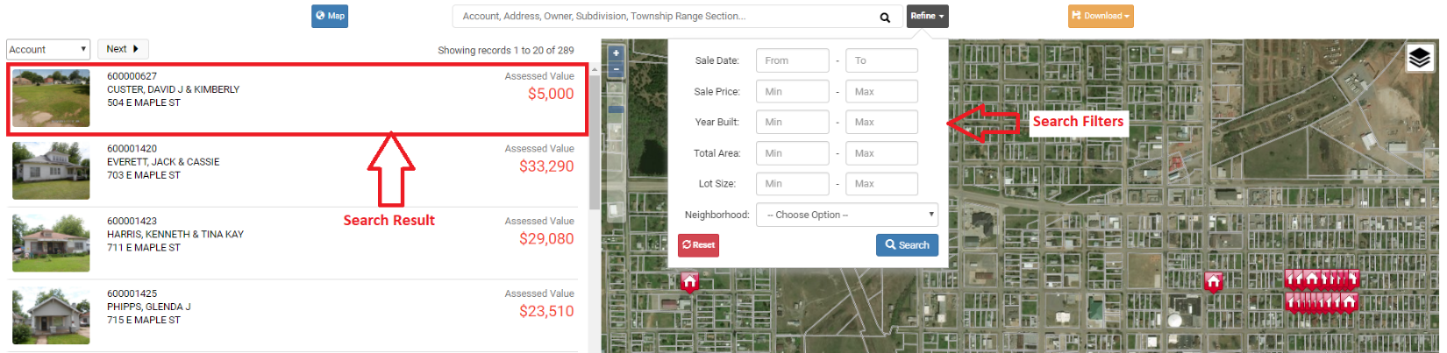
Figure 2

Record Card – Sales: Area and Neighborhood

The Area Sales view will display the closest 100 sales in the past 24 months to the property selected.
The Neighborhood Sales view will display 100 sales in the same neighborhood and in the past 24 months as the selected property. The date range can be changed to any number of months.

- What fields should be shown on the area sales view?
Property ID, Geo ID (Parcel Number), Property Type, sale date. .Sale Price, Acres(lot size), Year Built, Improvement Description, Address, Land Use, Distance,
- What fields should be shown on the neighborhood sales view? If this is not configured it will default to the same fields as area sales.
Property ID, Geo ID (Parcel Number), Property Type, sale date. .Sale Price, Acres(lot size), Year Built, Improvement Description, Address, Land Use, Distance,

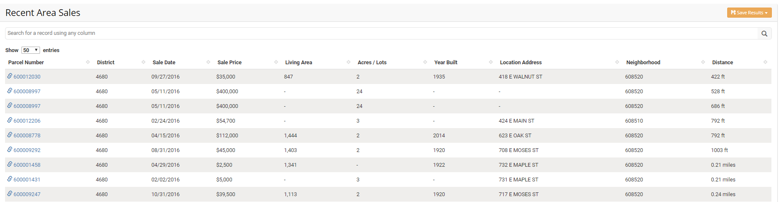

Record Card Information.

- The header consists of 3 sections max. (Header Section, Figure 3)
    - Parcel ID & Property location
    - Mailing Address
    - Value (Assessed/Market)
The way it is right now is great.

Parcel ID and value can be changed.
The highlight color can also be changed on request.

- What information should be displayed in the Key Information section? (Key Information, Figure 3). This section has
Looks good, Improvement Description, and Living area sq footage (with Basement if there is a basement) Also the Subdivision number is ok but I would like to include the ‘name’
(maybe the most recent sale?)

- What information should be displayed in Assessment Details section? (Assessment Details, Figure 3). This section has no data limit. The section title can be changed, and a tooltip added if required.

- External links can be added to the Navigation bar i.e. other products, other tools.
View Sales, Find Comparable, Community, Auditor Documents, Plats,

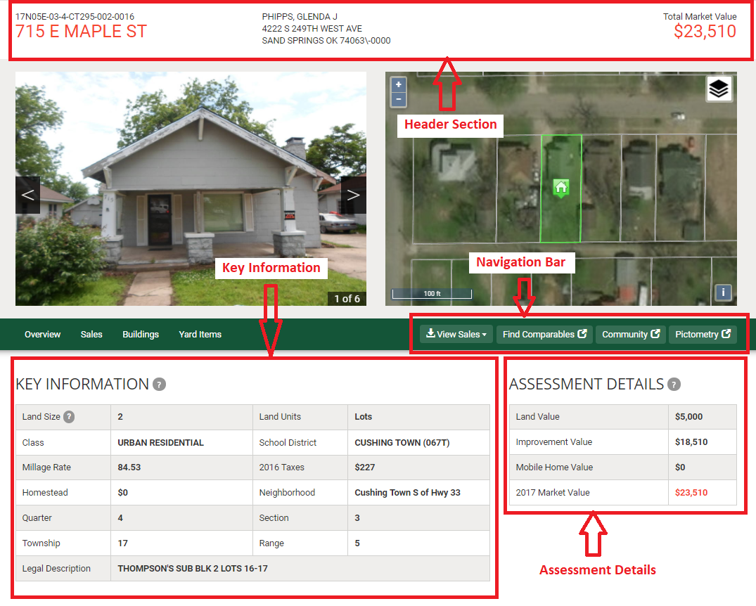 Figure 3 – Property Summary

Record Card Information - Buildings.

- What information is required for the buildings section? (Building Details, Figure 4). This section has no data limit. The section title can be changed, and a tooltip added if required. Like what is listed below. Type, Style, Qlty, Cond, Bed/Bathrooms, sq/ft, year built, siding and roofing type…

- What information is required for the improvements section? (Improvements, Figure 4). This section has no data limit. The section title can be changed if required. Yes, like the detail features, pole bldgs., pools, covered porches, decks…etc.

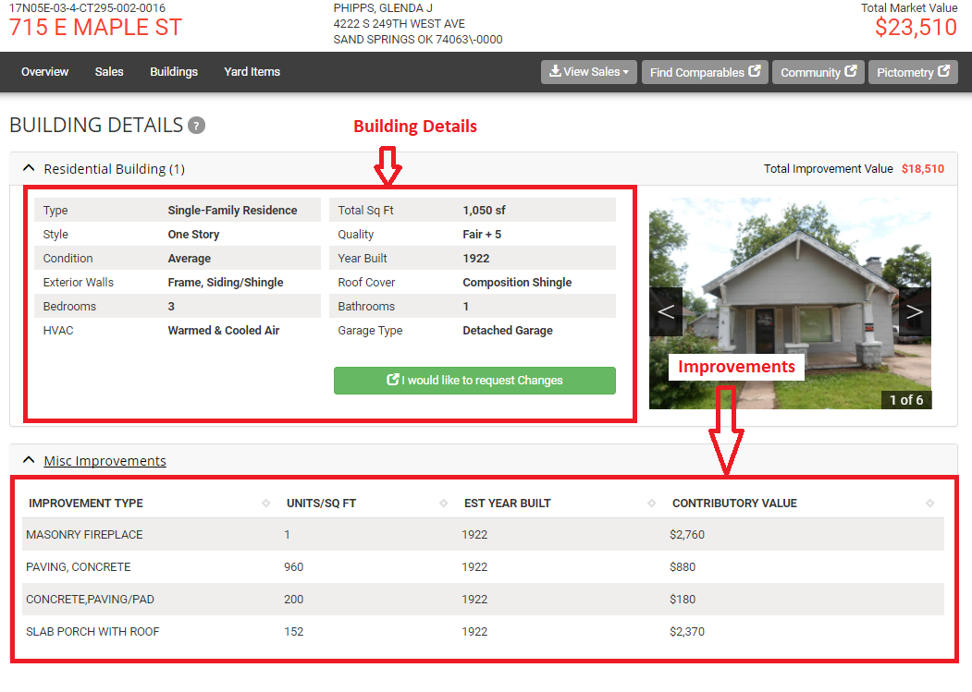
Figure 4 – Building details

Record Card Information – Change Request

- Is the change request functionality required? ? It isn’t required but would like to have.
- If so, what property characteristics are required? (Figure 5) What is listed below looks good for now.
- What is the adjourn date? What is meant here?
- What email address should be used for notifications of change requests? assessor@co.benton.wa.us – is this what we want to use?
- What text should be displayed for the “Equalization Reminder”? What is meant here?

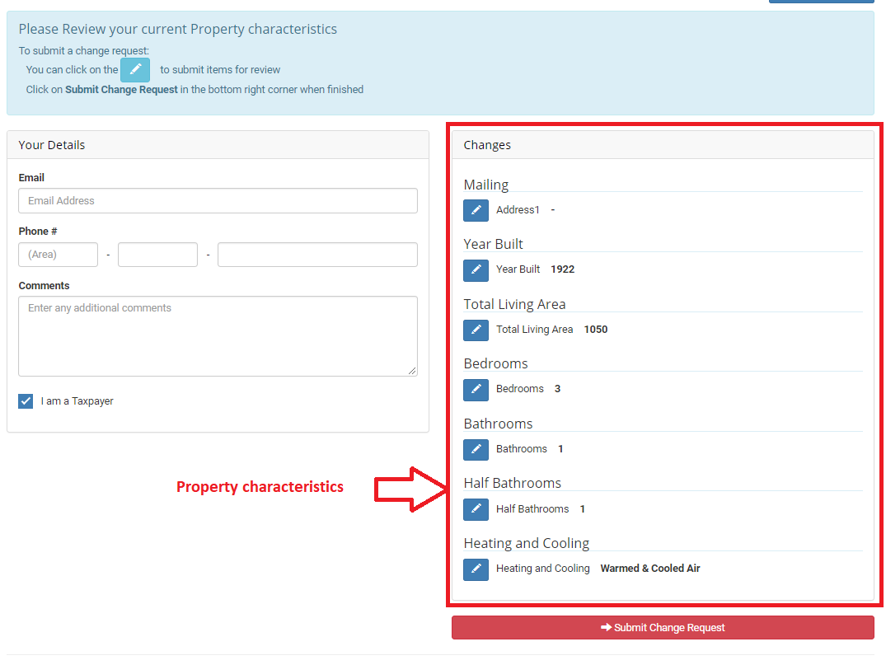
Figure 5 – Change Request

Record Card Information – Additional Tabs

Additional tabs can be added if required.

- Title (required) Good
- Tooltip (optional) Does this walk through how to do or?
- Pre-content – A paragraph can be added above the data table (optional)
- Data to show (required) like below, Sale Date/Price, Excise Number or recording number, Deed Type, Grantor and Grantee?

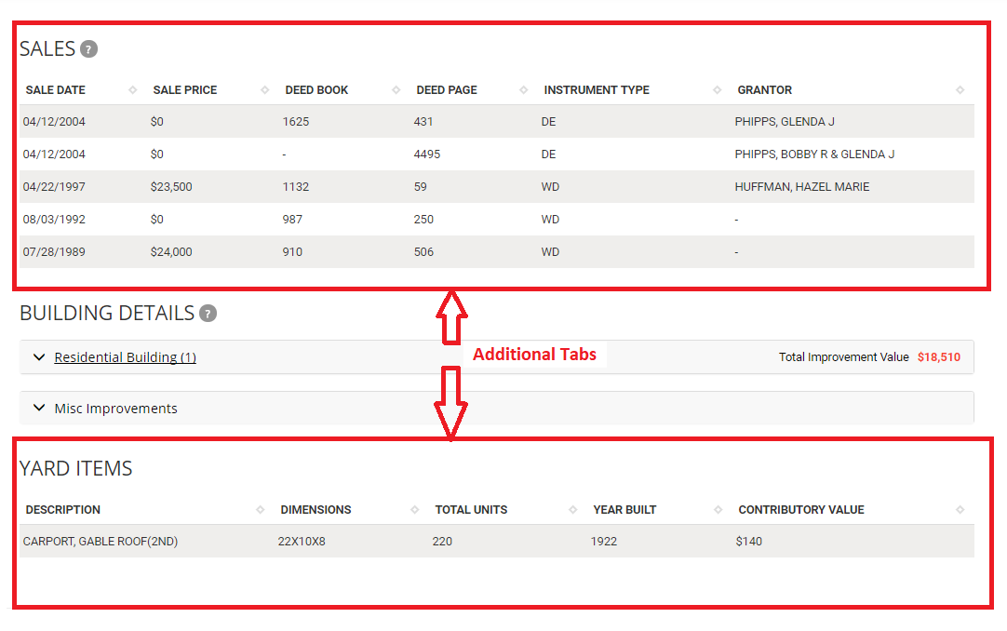
Figure 6 – Additional tabs

Tax info like on our site 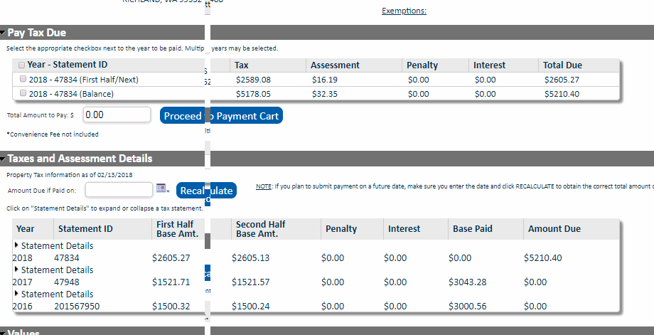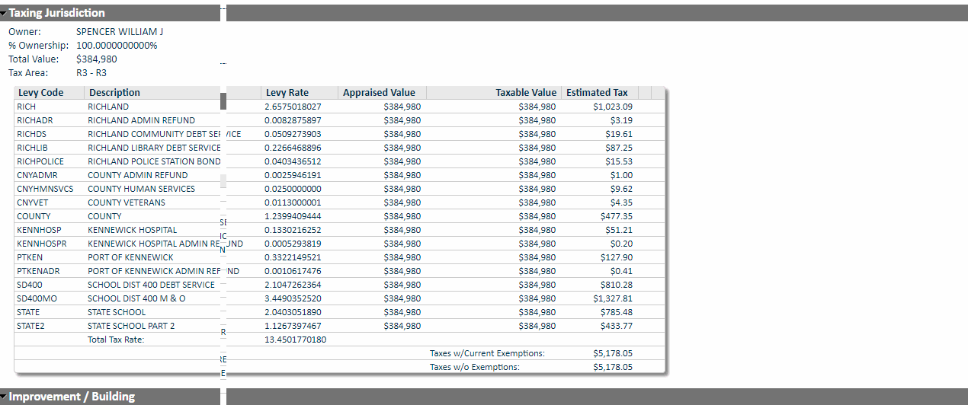

Map

- What additional Map Layers are required? Links to shapefiles etc

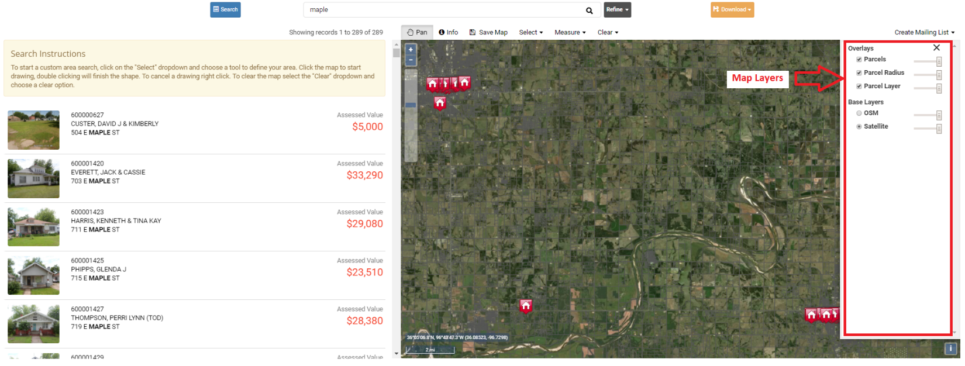
Figure 7 – Map view

Name: CityLimits
https://services7.arcgis.com/NURlY7V8UHl6XumF/ArcGIS/rest/services/Base_Map_Layers/FeatureServer/14

Name: LegislativeDistrict
https://services7.arcgis.com/NURlY7V8UHl6XumF/ArcGIS/rest/services/Base_Map_Layers/FeatureServer/4

Name: SchoolDistrict
https://services7.arcgis.com/NURlY7V8UHl6XumF/ArcGIS/rest/services/Base_Map_Layers/FeatureServer/11

Name: IrrigationDistrict
https://services7.arcgis.com/NURlY7V8UHl6XumF/ArcGIS/rest/services/Base_Map_Layers/FeatureServer/12

Name: CommissionerDistrict
https://services7.arcgis.com/NURlY7V8UHl6XumF/ArcGIS/rest/services/Base_Map_Layers/FeatureServer/2

Name: Zoning2011
https://services7.arcgis.com/NURlY7V8UHl6XumF/ArcGIS/rest/services/Base_Map_Layers/FeatureServer/13

City of Richland plats, short plats etc..
https://services3.arcgis.com/5g4JcCVJwbhPOszb/arcgis/rest/services/DivisionBoundaries/FeatureServer

City of Richland Zoning
https://services3.arcgis.com/5g4JcCVJwbhPOszb/arcgis/rest/services/ZoningAGISOL/FeatureServer

https://services7.arcgis.com/NURlY7V8UHl6XumF/arcgis/rest/services/Planning_Base_2/FeatureServer

https://bentonco.maps.arcgis.com/apps/webappviewer/index.html?id=428dcedbce17467b841844e8908bf3e7
https://bentonco.maps.arcgis.com/apps/View/index.html?appid=9264d720dc3a4caca03b783aedf38e78

https://services7.arcgis.com/NURlY7V8UHl6XumF/ArcGIS/rest/services/Base_Map_Layers/FeatureServer
Layers:
Section (0)
Township (1)
CommissionerDistrict (2)
ElectionDistrict (3)
LegislativeDistrict (4)
Topo_DNR_Benton_40 (5)
Landmark_FireStation (6)
FireDistrict (7)
Landmark_Hospital (8)
Hospital_District (9)
Landmark_School (10)
SchoolDistrict (11)
IrrigationDistrict (12)
Zoning2011 (13)
CityLimits (14)

